## Reports Menu/Daily Reports/Log Copy Label Activity

Request:

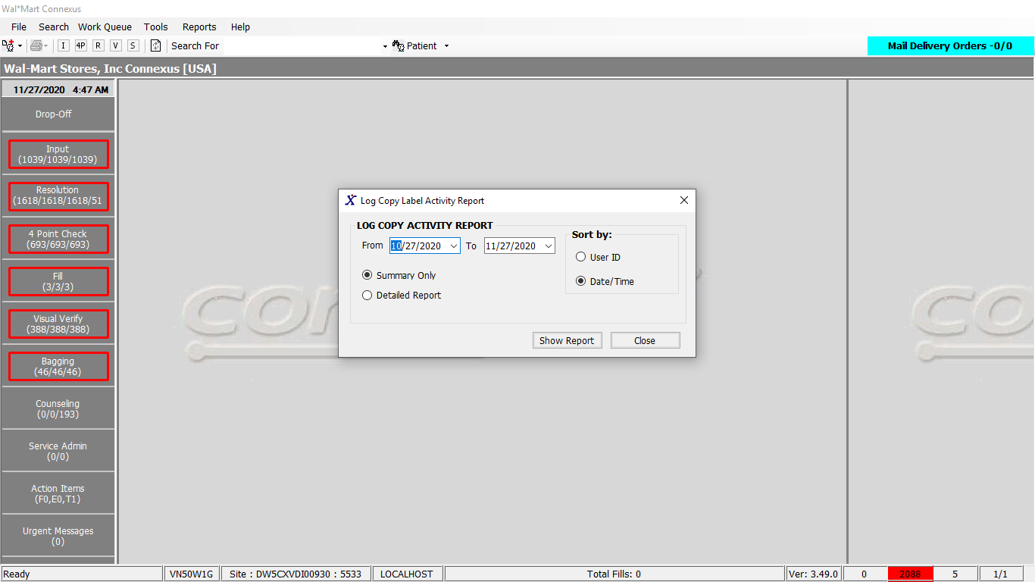

Response:

Summary Report:

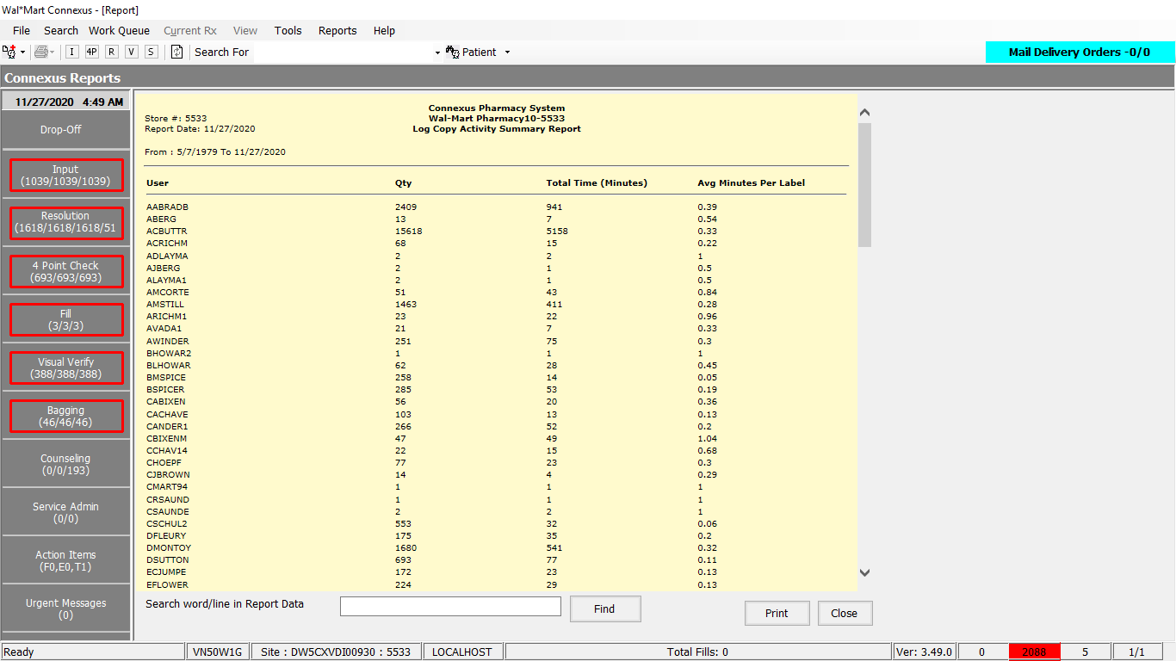

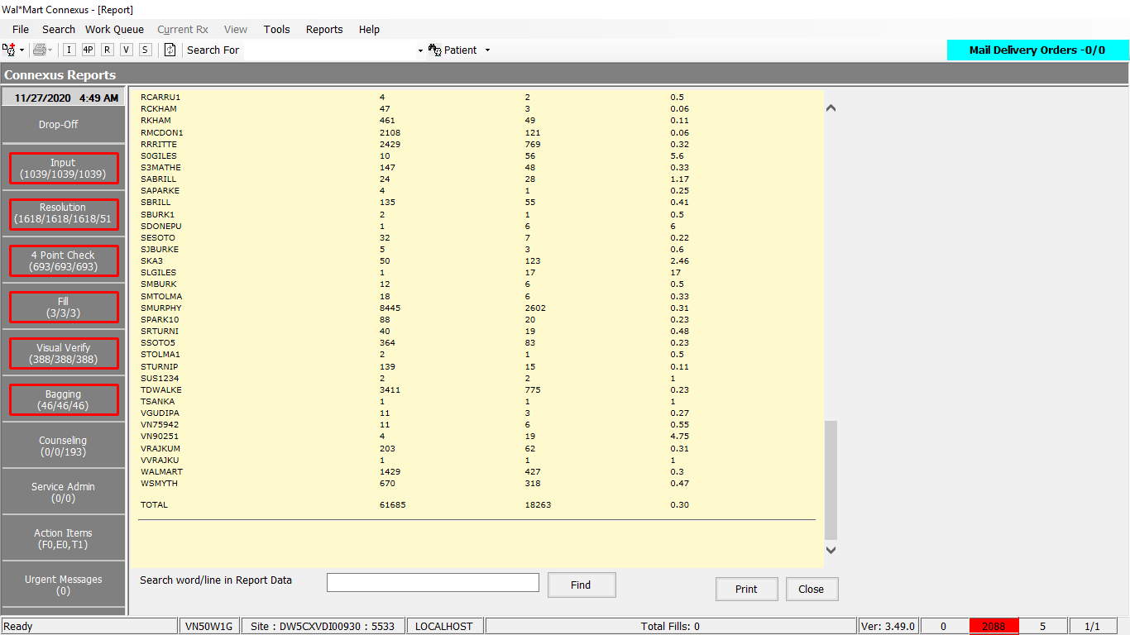

Detailed Report:

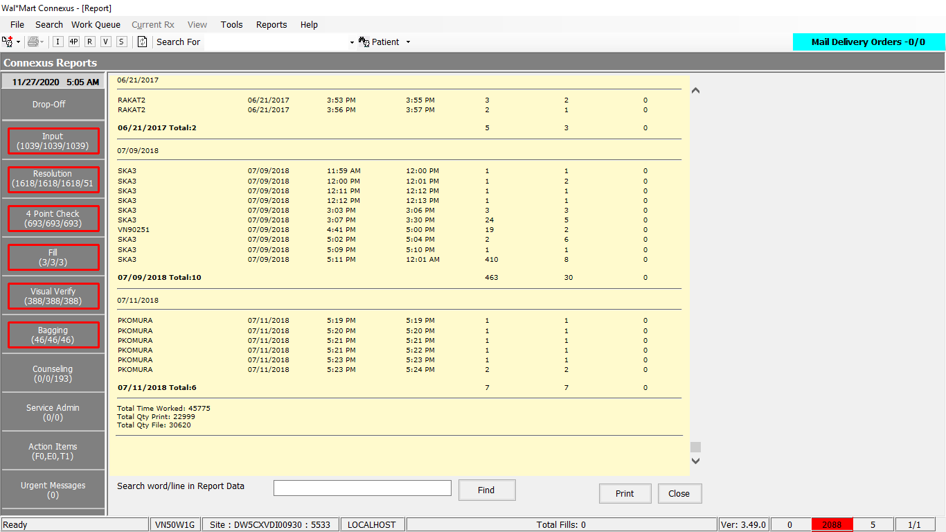

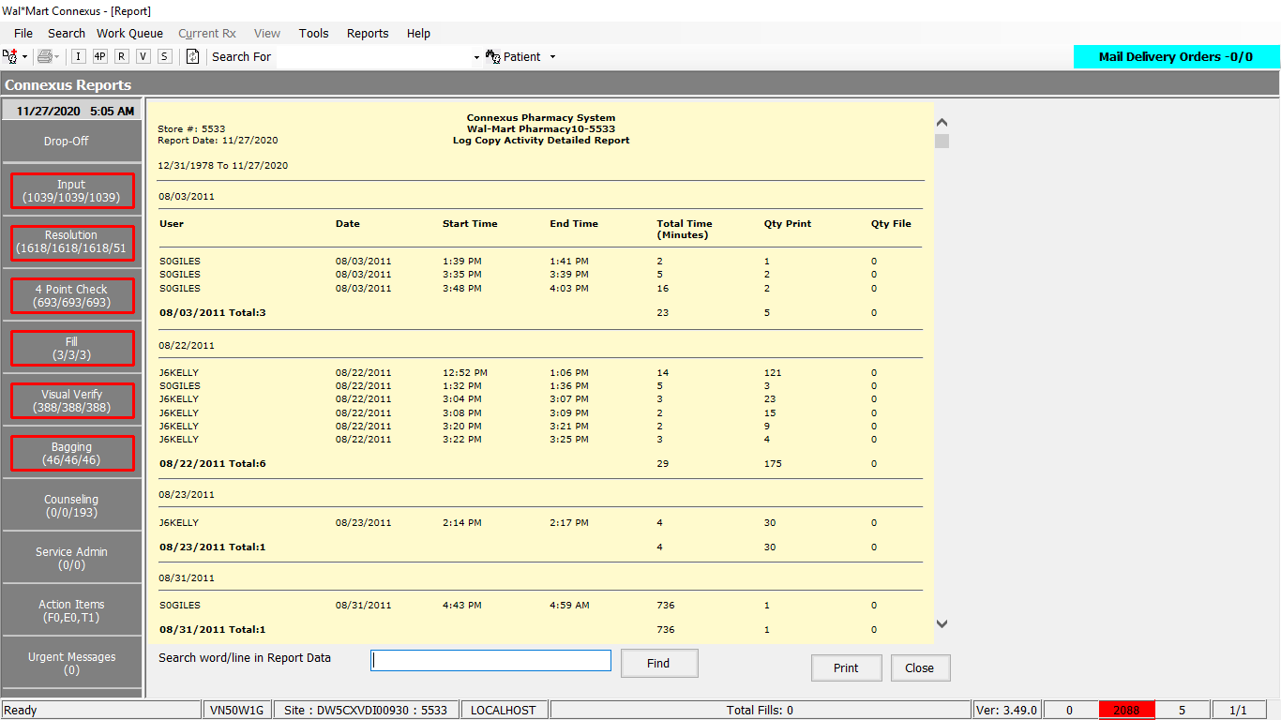

Queries:

Friend Const GetEodActivitySummaryReport As String = "SELECT a.userid UserId,a.activity_ts login ,b.activity_ts logout, " &

"count(*) Qty " &

"from error_and_audit : appl_activity a, error_and_audit : appl_activity b, " &

"rx21c : rx_activity c " &

"where a.userid = b.userid " &

"and a.activity_id = b.sys_term_id " &

"and a.userid = c.activity_userid " &

"and activity_code in (32659,32660,32661)" &

"and c.activity_ts between a.activity_ts and b.activity_ts " &

"and a.activity_type_code = 1025 " &

"and b.activity_type_code = 1026 " &

"and a.activity_result_code = 1002 " &

"and b.activity_result_code = 1002 " &

"and b.activity_ts > a.activity_ts " &

"and a.activity_ts <> '0001-01-01 00:00:00.00000' " &

"and b.activity_ts <> '0001-01-01 00:00:00.00000' " &

"and a.userid is not null " &

"and b.userid is not null " &

"and date(a.activity_ts) between ? AND ? " &

"group by a.userid,a.activity_ts ,b.activity_ts "

DAL:

Public Function GetLogCopyActivitySummaryReport(ByVal siteId As Integer, ByVal fromDate As Date,

ByVal toDate As DateTime, ByVal sortOption As Integer) _

As List(Of LogCopyActivitySummaryBE) Implements IReportDAL.GetLogCopyActivitySummaryReport

Dim getLogCopyActivitySummaryList As New List(Of LogCopyActivitySummaryBE)

Dim getLogCopyActivitySummary As LogCopyActivitySummaryBE = Nothing

Dim sqlString As New StringBuilder

sqlString.Append(ReportQueries.GetEodActivitySummaryReport)

Dim paramList As New List(Of DbParameter)

paramList.Add(ParameterHelper.BuildParameter("fromDate", DbType.Date, fromDate))

paramList.Add(ParameterHelper.BuildParameter("toDate", DbType.Date, toDate))

sqlString.Append(" order by a.userid,a.activity_ts")

Dim datareader As IDataReader = ExecuteReader(DatabaseEnum.rx21c, siteId, sqlString.ToString, paramList)

While datareader.Read

getLogCopyActivitySummary = New LogCopyActivitySummaryBE

If Not datareader.IsDBNull(datareader.GetOrdinal("UserId")) Then

getLogCopyActivitySummary.ActivityUserId = CStr(datareader("UserId")).Trim

End If

If Not datareader.IsDBNull(datareader.GetOrdinal("logout")) And Not datareader.IsDBNull(datareader.GetOrdinal("login")) Then

getLogCopyActivitySummary.TotalTimeInMinutes = (Convert.ToDateTime(datareader("logout")) - Convert.ToDateTime(datareader("login"))).Minutes + 1

End If

If Not datareader.IsDBNull(datareader.GetOrdinal("Qty")) Then

getLogCopyActivitySummary.PrintQty = CInt(datareader("Qty"))

Else

getLogCopyActivitySummary.PrintQty = 0

End If

If Not datareader.IsDBNull(datareader.GetOrdinal("Qty")) Then

getLogCopyActivitySummary.AvgMinutesPerLabel = Math.Round(CDbl(getLogCopyActivitySummary.TotalTimeInMinutes / getLogCopyActivitySummary.PrintQty), 2)

End If

getLogCopyActivitySummaryList.Add(getLogCopyActivitySummary)

End While

If getLogCopyActivitySummaryList.Count > 0 Then

Return getLogCopyActivitySummaryList

Else

Return Nothing

End If

End Function